How stone tools were made?
How stone tools were made? |  |  | Video question

Name︰_______________ （ ） Class︰__________

Related Textbook Content | 1A pp.8-12

Watch the video below and answer the following questions.

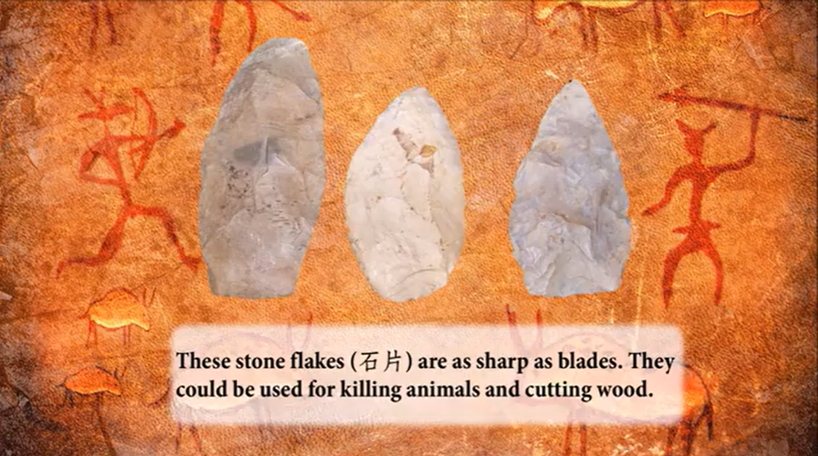
Link: https://youtu.be/gHRRrOYQEjY  Duration: 2m 05s  Introduction: Introduce ancient humans’ ways of making stone tools and their different functions. | 

Choose the correct answers and put them in the boxes.

1. | Which period of human life does the video reflect?  A. Stone Age  B. Bronze Age  C. Iron Age  D. Silver Age
2. | Around when did people start making stone tools?  A. 3 million years ago  B. 2.5 million years ago  C. 2 million years ago  D. 1.5 million years ago
3. | Which of the following was not a purpose for the Old Stone Age humans to make stone tools?  A. Cutting woods  B. Building houses  C. Killing animals  D. Hunting animals
4. | Which of the following was not used by the ancient humans to polish (磨製) stone tools?  A. Wood  B. Ivory (象牙)  C. Antler (鹿角)  D. Rubber

Answer the questions according to the video above.

5. How did ancient humans create stone tools?
________________________________________________________________________

6. Which were the two types of stones do ancient humans use to make stone tools? Why?
________________________________________________________________________
Answers

1. A

2. B

3. B

4. D

5. Ancient humans knocked two rocks together to make different shapes of tools.

6. Flint and obsidian. Because they were harder, they would shatter into sharp pieces. It was therefore easier to make sharp tools.

